
RAMAIAH
Institute of Technology
USN | 1 | M | S

(Autonomous Institute, Affiliated to VTU)
(Approved by AICTE, New Delhi & Govt. of Karnataka) Accredited by NBA & NAAC with ‘A+’ Grade

EXAMINATIONS SEPTEMBER /OCTOBER 2021
SUPPLEMENTARY SEMESTER / GRADE IMPROVEMENT/ RE –REGISTERED CANDIDATES
Program | : | B.E. : Computer Science and Engineering | Semester | : | V
Course Name | : | Database Systems | Max. Marks | : | 100
Course Code | : | CS52 | Duration | : | 3 Hrs

Instructions to the Candidates:
- Answer any five full questions.

1. | a) | Discuss the characteristics of database approach. | CO1 | (06)
 | b) | Identify the different set of end users in database management systems. | CO1 | (06)
 | c) | Map the following E-R diagram into relational schema. Explain each step in detail.  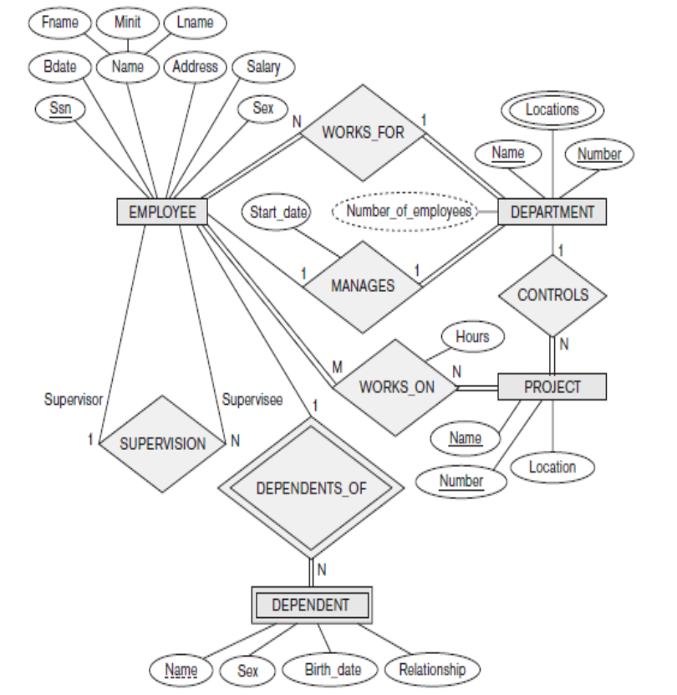 | CO1 | (08)
2. | a) | What is data independence? How this is achieved with three scheme architecture? Explain with a neat diagram. | CO1 | (05)
 | b) | Explain database system environment with the help of a neat diagram. | CO1 | (05)
 | c) | Define participation constraint. Explain its types by considering suitable example. | CO1 | (05)
 | d) | Discuss the three schema architecture in detail. | CO1 | (05)
3. | a) | Define union compatibility of relations. Explain the set theoretical operations in relational algebra with example. | CO2 | (06)
 | b) | Assume that you have two relations R & S where R is parent relation and S is child relation. R has primary key values where S references them. In a situation you are about to delete some tuples in relation R which causes inconsistency in relation S.As a designer what solution you might suggest to avoid inconsistencies in relation S? | CO2 | (04)
 | c) | Consider the following schema:  Suppliers(sid , sname , address)  Parts(pid, pname, color)  Catalog(sid, pid, cost)  The key ﬁelds are underlined.Therefore sid is the key for Suppliers, pid is the key for Parts, and sid and pid together form the key for Catalog. The Catalog relation lists the prices charged for parts by Suppliers. Write the following queries in relational algebra  i. Find the names of suppliers who supply some red part.  ii. Find the sids of suppliers who supply some red or green part.  iii. Find the sids of suppliers who supply some red part or are at Mysore.  iv. Find the sids of suppliers who supply some red part and some green part.  v. Find the sids of suppliers who supply every part. | CO2 | (10)
4. | a) | Discuss the division operation in relational algebra with an example. | CO2 | (04)
 | b) | Consider the following two relations. Show the resultant relations after applying left outer join, right outer join and full outer join.  R S | CO2 | (07)
  ID | Name |  | ID | Address
  1 | Abhi |  | 1 | Delhi
  2 | Adam |  | 2 | Mumbai
  3 | Alex |  | 3 | Chennai
  4 | Anu |  | 7 | Noida
  5 | Ashih |  | 8 | Panipat
 | c) | Explain the rename operation in relational algebra with an example. | CO2 | (04)
 | d) | Discuss the aggregate functions of relational algebra with its syntax by considering relational schema that has at least one numerical attribute. Display the results after you apply each operation. | CO2 | (05)
5. | a) | Explain any three different clauses of SELECT in SQL with an example. | CO3 | (06)
 | b) | What do you mean by nested queries in SQL? Why IN operator is preferred over JOIN in nested queries? Explain with an example. | CO3 | (04)
 | c) | Consider the following schema.  SAILORS(SID,SNAME,RATING,AGE)  BOATS(BID,BNAME,BCOLOR)  RESERVES(SID,BID,DAY)  Formulate the SQL queries for the following.  1. Create the above tables by imposing the following constraints  i. Rating can be an integer between 1 and 10 only  ii. Boats name should be ‘Jackpot’,’Zameen’,’Interlake’  2.Find the names of sailors who have reserved Yellow boat but not Orange boat  3.Find the names of sailors who have not reserved Interlake boats  4.Find the names of sailors who are older than oldest sailor with a rating of 10  5. For each red boat find the number of reservations made. | CO3 | (10)
6. | a) | Explain the purpose and syntax of the following commands in SQL by considering an relational schema that has at least one numerical attribute.  - Delete ii)Update iii)Alter iv) Grant v) Revoke. | CO3 | (10)
 | b) | Explain specification, implementation and update of views in SQL with example. | CO3 | (05)
 | c) | What are database stored procedures? Give general forms for declaring a procedure. | CO3 | (05)
7. | a) | Discuss the informal design guidelines for relational schema in detail. | CO4 | (08)
 | b) | Assume a relation R is defined over the attributes R(A,B,C,D,E,F) and the functional dependencies are F={A→C,AC→;D,E→AD,E→F) and G={A→CD,E→AF}.Check whether G and H are equivalent or not. | CO4 | (06)
 | c) | Define fully functional dependency. Explain the 2 NF with an example. | CO4 | (06)
8. | a) | Let R = ABCDE, R1 = AD, R2 = AB, R3 = BE, R4 = CDE, and R5 = AE. Let the functional dependencies be: A -> C, B -> C, C -> D, DE -> C, CE -> A  Apply algorithm to test if the decomposition of R into {R1,..,R5} is a lossless join decomposition or not. | CO4 | (08)
 | b) | Consider the relation R, which has attributes that hold schedules of courses and sections at a university; R = {Course_no, Sec_no, Offering_dept, Credit_hours, Course_level, Instructor_ssn, Semester, Year, Days_hours, Room_no, No_of_students}.  Suppose that the following functional dependencies hold on R:  {Course_no} → {Offering_dept, Credit_hours, Course_level}  {Course_no, Sec_no, Semester, Year} → {Days_hours, Room_no, No_of_students, Instructor_ssn}  {Room_no, Days_hours, Semester, Year} → {Instructor_ssn, Course_no, Sec_no} Try to determine which sets of attributes form keys of R. How would you normalize this relation? | CO4 | (06)
 | c) | Define transitive dependency. Explain 3 NF with an example. | CO4 | (06)
9. | a) | What is meant by the concurrent execution of database transactions in a multiuser system? Discuss why concurrency control is needed, and give informal examples. | CO5 | (07)
 | b) | Discuss the actions taken by the read_item and write_item operations on a database. | CO5 | (06)
 | c) | What is the system log used for? What are the typical kinds of records in a system log? What are transaction commit points, and why are they important? | CO5 | (07)
10. | a) | Which of the following schedules is (conflict) serializable? For each serializable schedule, determine the equivalent serial schedules.  i. r1(X); r3(X); w1(X); r2(X); w3(X);  ii. r1(X); r3(X); w3(X); w1(X); r2(X);  iii. r3(X); r2(X); w3(X); r1(X); w1(X);  iv. r3(X); r2(X); r1(X); w3(X); w1(X) | CO5 | (10)
 | b) | What is the two-phase locking protocol? How does it guarantee serializability? | CO5 | (06)
 | c) | What is a timestamp? How does the system generate timestamps? | CO5 | (04)

****************

